Lesson Plan: Playing with Food Scraps

A hands-on series of classroom activities about playing and getting creative with food scraps

Grade Level | Grades K-7
Season | Any season
Difficulty Level | 

Teacher Background

Overview
This lesson offers ways for students to learn about reducing and reusing waste in engaging ways, through hands-on play and scientific exploration in both indoor and outdoor classroom settings. These activities can be completed as stand-alone activities or one after the other. The plans are aimed at grades K-7, although can be easily adapted for all grade levels through learning extensions.

Learning Objectives
Students will be able to:
- Use creativity to comprehend and explore new activities that can be done with food scraps and waste such as making art
- Understand how to regrow food scraps
- Discuss and think critically about food waste practices
- Learn about life cycles through sprouting seeds from food waste
Curriculum Connections

 | Curricular Competencies | Content
Applied Design, Skills, and Technology | - Identify needs and opportunities for designing, through exploration (Gr.K-3)  - Identify and evaluate the skills and skill levels needed, individually or as a group, in relation to a specific task and develop them as needed (Gr.4-7) | - Food studies (Gr.6-7)
Physical Health Education | - Develop and demonstrate safety, fair play, and leadership in physical activities (Gr.K-7) | - Practices that promote health and well-being (Gr.K-7)
Science | - Demonstrate curiosity about the natural world (Gr.4)  - Experience and interpret the local environment (Gr.6) | - Seasonal changes; plants and animals; biodiversity; knowledge of local First Peoples of ecosystems (Gr.K-3)  - Sensing and responding: plants (Gr.4)  - First Peoples concepts of interconnectedness in the environment (Gr.5)
First Peoples’ Principle | “Learning ultimately supports the well-being of the self, the family, the community, the land, the spirits, and the ancestors.”  The activities in this series will allow opportunities for students to reflect on the food system. All of this learning ultimately contributes to the land, teachings from the community, and impact on future generations.
Classroom Activities

Table of Contents
Regrow Food Scraps 4
Seeds from Food Scraps 7
Food Stamp Paper 9

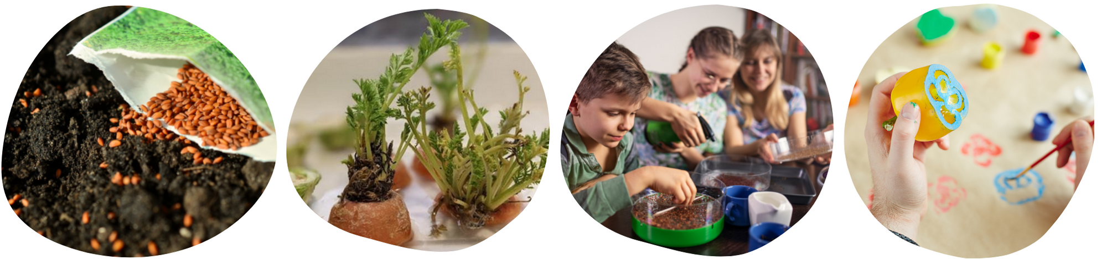

Regrow Fruit and Vegetable Scraps Difficulty:

Resprout fruit and vegetable scraps in jars of water

Time: 20 minutes to set up, 1-2 weeks to document growth

Materials
- Vegetable/fruit scraps. Students could bring these in from home, or you could ask the Foods class or school lunch program staff to set aside some scraps.
- Jars or any type of recycled container
- Water
- Optional: soil & pots
- Optional: Partner with your buddy class or younger grade to try this resprouting experiment together!

Steps
- Students select fruit or vegetable scraps to regrow. Vegetables that work well include:
- Celery (base where all the celery ribs connect)
- Green onions (the root end with about 5 cm of the green onion)
- Carrot (tops with about 5 cm of carrot)
- Beets (tops with about 3 cm of beet)
- Romaine lettuce (at the base where all the leaves connect)
- Others - experiment to see what else students would like to try and grow!
- Place food scraps in a container in the direction they would be found in nature. For example, beets and carrots are root vegetables, so the cut vegetable side goes face-down. Green onions, celery and romaine lettuce all grow upwards, so they are placed in water cut side up.
- Fill the container with water so the food scrap is about half covered.
- Place containers in a window with natural light.
- Change or top up the water every other day.
- Allow students to observe or document change and growth.
- Once roots start sprouting, you can continue to observe growth in water or transfer sprouting scraps into soil to allow them to continue growing.

For most scraps, you will not get any harvestable produce, but you can certainly observe growth and experiment to see what sprouts. See some examples below.

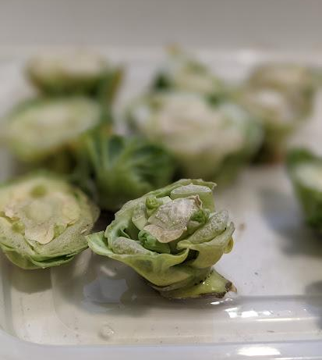  Brussels Sprouts | 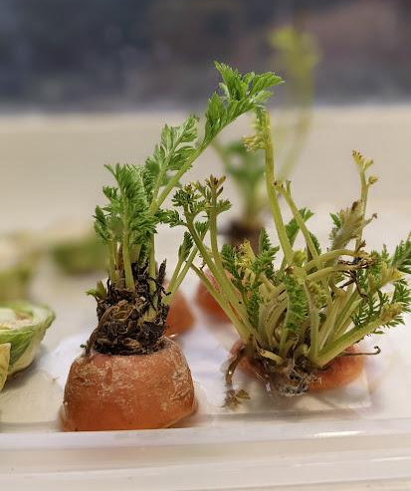  Carrots
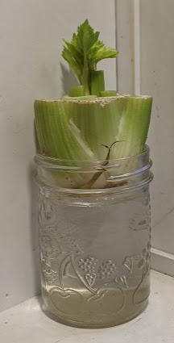  Celery | 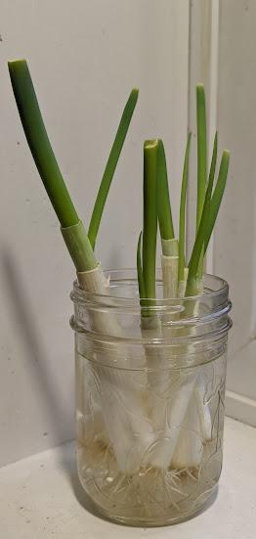  Green Onions

Cross-Curricular Activities
- Math: Measure growth regularly, graph the results.
- Science:
  - Colour the water with food colouring and watch the plant absorb the coloured water.
  - Connect to life cycles of plants from seed to harvest.
  - Experiment with growing the plants by a window, under grow lights (or other lights you have on hand), or just under the regular classroom lights. Does the light affect plant growth?
- PHE: Safely prepare food with the tops of foods as they grow, to add to a salad, tacos or tostadas.

Extensions
- If you would like to grow something else, Sweet Potato Heads are a fun project to grow with children.
- If you have any decorative corn cobs around, you can also sprout them in your classroom.

Sprouting Seeds from Food Scraps Difficulty:
Instead of tossing seeds into the compost, see if you can sprout them!

Time: 30 minutes, monitor over several days

Materials
- Vegetable/fruit scraps. Students could bring these in from home, or you could ask the Foods class or school lunch program staff to set aside some scraps.
- Soil or wet paper towel
- Recycled containers (shallow plastic ones work best)
- Water
- No light is needed for this activity, great to do in a classroom with no windows.

Note: Keep in mind, the idea of this activity is not to produce fruit-bearing plants. Many of the seeds that you harvest from produce purchased from the grocery store will not create plants able to produce fruit. This activity can simply be a trial and error experiment to see what seeds sprout and to observe the sprouting process.

Steps
- Prepare recycled containers with a small amount of soil or 1-2 damp paper towel sheets placid at the bottom.
- From the food scraps, select a variety of fruits and vegetables to grow seeds from.
- Using the Farm to School BC Seed Saving lesson plan as a guide, harvest a variety of seeds and seed types from various food scraps. Try seeds from any fruits or vegetables to see how they sprout! Here’s a list of fruit and vegetables to get you started:
- Tomato
- Pepper
- Lemon/lime
- Green bean
- Squash
- Apple
- Cucumber
- Melon
- Place the seeds on top of the damp paper towel or on top of the surface of the soil.
- Keep the seeds moist.

Cross-Curricular Activities
- Math: You can do several measuring or counting activities with the seeds, looking at the percentage/decimal/fraction of the seeds that germinated.
- PHE: How do plants grow? Learn more about how plants grow from seeds.
- Science: Using daily journals and predictions, following scientific procedure (for example with pole beans) of how seeds sprout.

Extensions
Once seeds have sprouted and you have observed the process, you can compost the seedlings with a Pop Bottle Composter. In the spring, these seedlings can be planted outside. You can also plant flowers or herbs seeds, that can be given as gifts or used in a school fundraiser!

Food Scrap Stamps Difficulty:
Make creative wrapping paper or postcards with stamps made from food scraps
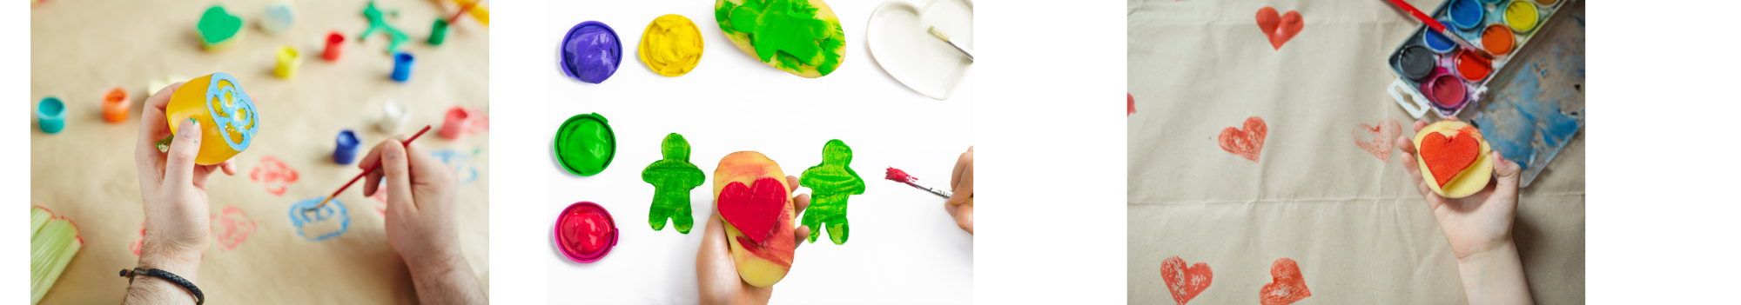
Materials
- Vegetable/fruit scraps. (Students could bring these in from home, or you could ask the Foods class or school lunch program staff to set aside some scraps.)
  - Examples include apple peels, peppers tops, celery base, carrots cut ends, and beet tops etc.
  - Foods can be stamped as they are (i.e. cut side down of a celery based to make a flower pattern) or cut into new shapes with the help of an adult
- Large roll of brown craft paper - one large sheet of paper per student
- Water-based paint
- Review this video for teaching knife skills and safety

Note: This activity is intended for students to respectfully play and connect with parts of food in a different way. Fruit and vegetable pieces suggested for this activity are meant to be the pieces that would normally be thrown out or composted as a way of showing students an alternate way to reuse them. This activity is not intended to be done with whole fruits/veggies.

Steps

Before class preparation:
- Cut each student a large piece of brown craft paper (or have a class volunteer do this).
- Prepare paint stations for the students: pouring a small amount of paint into containers that will fit various shapes of stamps
- Arrange a variety of cut food scraps for students to choose from.

In class:
- Give each student a large sheet of brown craft paper.
- Allow them to select the food scrap stamps they would like to use and create patterns on their wrapping paper.
- Hang the wrapping papers to dry then allow students to roll them up and take them home.

Cross-Curricular Activities
- ADST: Use different foods as stamps, test out the different shapes that can be created with them,
- Math: Look at various shapes. Create patterns with the shapes.
- Art: Set up an art station in the corner and allow it to be messy. Also, look at how colours mix and create new colours for younger students.

Extensions
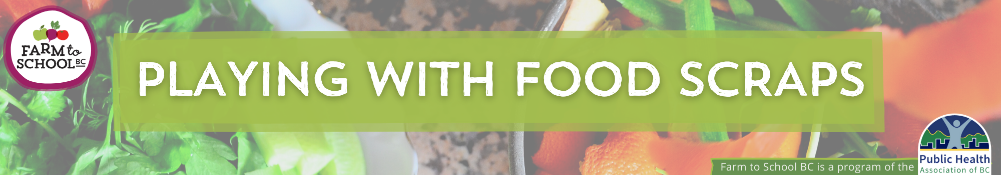
- Dyeing fabric with food scraps- find all the details and instructions in this presentation (Recycling and Environmental Action Plan Society in Prince George).

