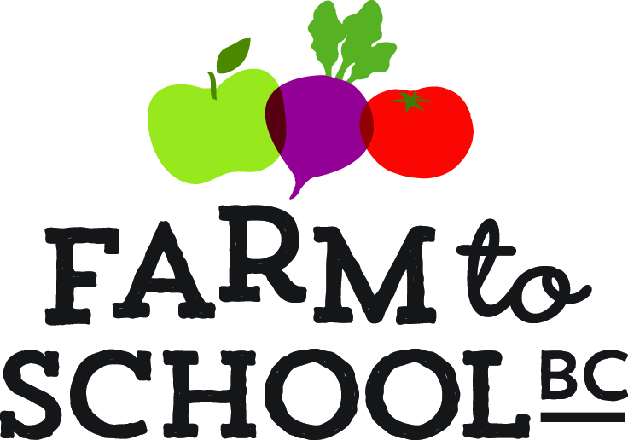
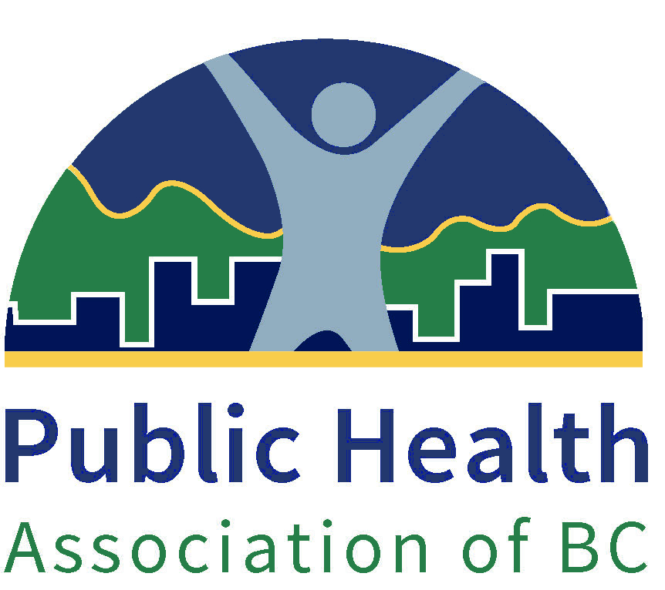
Farm to School BC – Bringing Healthy Local Food to Schools

Welcome to the Farm to School BC grant application page! Please read over the eligibility and exclusion criteria carefully before proceeding further.

About Farm to School BC
Farm to School BC is a diverse and expanding provincial network that promotes, supports, and links Farm to School activities and programs across the province. From school gardens and local food at lunch, to farm field trips and more, Farm to School activities help students learn about their local food system, teach important life skills and provide the opportunity for healthy habits to take root. Farm to School also benefits local farmers and suppliers.

Eligibility Criteria
- Must be a K- 12 school located in BC (If you are from a school in Vancouver School Board, please apply for Think&EatGreen@School Small Grant Application 2018-19 by clicking here (deadline October 24, 11:59pm).
- Note: Previous recipients of F2SBC (2014-2016) grants are eligible to receive up to $1,000 and schools that received funding prior to 2014 or without a prior history of receiving a F2SBC grant will be eligible to receive up to $3,500.

Exclusion criteria
- If you are currently holding another active Farm to School grant (i.e., Farm to School BC Grant recipient in 2017 or Farm to Cafeteria’s Salad Bar Grant recipient), you are not eligible to receive this grant.

Deadline: November 19, 2018

Important
Please note that you are able to go back and fourth between the application pages by pressing the “back” and “next” button located at the bottom of the screen. However, if you close the window, your progress will not be saved. We strongly encourage you to download and complete all forms before submitting online. The F2SBC signature form and any letters of support can be uploaded through our application page.

Before proceeding further, please ensure you have the following files:
- Completed Grant Application Form(required)
- F2SBC Signature Form (signature required)
- Letter(s) of Support (Optional)

Application Form:

School Information
School Name: |  |  |  |  | School District #:
Address:

Phone:

Website:

Entire Student Population: |  |  | All Grade Levels Taught at School:
Select School Type: | Elementary | Middle |  | Secondary | Independent | First Nations

Lead Applicant
Name: | Position:
What is the best way to reach you?
Email: | Phone:

Select the F2SBC grant you are eligible for*:
☐ Up to #3,500: Our school has never received a F2SBC grant before or the last time our school received a F2SBC grant was prior to 2014 | ☐ Up to $1,000: Our school has received a F2SBC grant prior between 2014 and 2016.
☐ Uncertain (please contact the Provincial Manager prov.manager@farmtoschoolbc.ca)

- Please check all the food-related activities and programs happening at your school (checkboxes)
  - School garden
  - Cooking classes/activities
  - Composting
  - School Fruit & Vegetable Nutritional Program
  - Preservation
  - Farm tour
  - Meal program
  - Vermicomposting
  - Microgreens
  - Seedling Sale
  - Salad Bar
  - Hydroponics
  - Fruit Tree Planting
  - Beekeeping
  - Other (text box)

- Describe what you plan to do if you are awarded this grant (text box)

- How many students do you anticipate will participate and benefit from the program? (fill in the blank)
  - Students
    - Grades

- How will your Farm to School activities integrate the core elements of Farm to School? (text box)

Core Elements | Description
Healthy local food
- How will your school source food locally? (e.g., farmers, community gardens, school garden, food distributors, grocery stores, etc…)

Hands-on Learning
- How will your activities align with the BC curriculum and enhance food literacy skills? (e.g., lesson plans, courses, field trips, science labs, etc…)

School-Community Connectedness
- How will your activities enhance your school’s connection to the broader community?

- It is important for grant recipients to ensure that their Farm to School program is sustainable.

Financial sustainability:
How will your school ensure you program is financially sustainable? Will you charge for you school garden program? How invested in this project is your school district and/or PAC? Will they provide monetary support?

Operational/Logistical sustainability:
How will your school ensure you program is operationally and logistically sustainable?
Are you going to host garden committee meetings? If so, how often? Who will chair these meetings?

Educational sustainability:
Is curriculum connected to your F2S activity? If so, how? If teachers are developing the curriculum, have you talked to your school district learning department about creating additional support and resources?

- Farm to School BC programs are most successful when there is a collective team effort (e.g. school administration, school staff, health authority partner, community supporter). Please list the members of your team and their respective duties/roles in the program. Please note that not all positions need to be filled (minimum of 2 supporters).
  - Column for name
  - Column for title
  - Column for Organization/Affiliation
  - Column for roles/responsibilities for the F2SBC program
  - Column for contact information (phone or email)

- Environmental Health Officers (EHO) are valuable points of contact for assisting schools in ensuring that their plans meet regulation standards if they involve using food. They may also be able to assess some of the food safety practices of the farms or market gardens supplying your food as well. Although some school proposals do not require EHO approval, we strongly recommend that you involve them in your program. (If you are unsure who your local EHO is, please check our EHO contact list here. If you still cannot identify your local EHO, please contact your respective Public Health Dietitian - https://farmtoschoolbc.ca/about-us/our-team/) (check box)
  - Our Farm to School program does not require consultation from the EHO
  - We are already or will be working together with an EHO name and contact information of EHO

- Please provide a budget for your proposed Farm to School program.
  - Table to contain various items (e.g., kitchen equipment, workshop, honorarium, travel, garden supplies, etc…) along with approximate price
  - In-kind contribution
  - Additional funding sources
  - Labour costs (if applicable)

- Although a Farm to School team is diverse, it is especially important that school administrators are informed and have pre-approved your application. Please submit the ‘Farm to School BC Signature Form’ with signatures attached.

- Optional: Please attach any letters of support (e.g., community partner, school district):

- Successful recipients of the grants have a few responsibilities:
  - Submit a financial report (template to be provided) accompanied by all receipts by June 2019 and June 2020. We require that all schools spend most of their funds by the end of the 2019 - 2020 school year.
  - Submit a school year-end report for the 2018/19 and 2019/20 school years ( for 2 years)
  - Submit pictures that showcase program progress (submitted with the year-end reports).

Please let us know who will be the contact person for submitting these deliverables (must have at least two people).

 | Name | Contact Information (email and/or phone)
Main contact | 1.
Alternative | 2.

Cheque Information
Please provide the full legal name and address of the school. Please note that the cheque cannot be made out to an individual.

Cheque to be made out to
School Name
School Address
Attention:

Contact Person for the Cheque (name & contact info): _____________________________

Title: Evaluation of F2SBC

Farm to School BC is planning to evaluate the impact of the program on students and the school community. If you are a successful recipient of a F2SBC grant, we would like to invite your school to participate in our evaluation. We plan to use a mix of qualitative and quantitative methods (online surveys, key informant interviews with students, parents, teachers and school administrators, focus groups). Your participation is voluntary and you can opt out at any time. More information will be provided at a later date.

Would you be interested in participating in the evaluation process of our program?
(Note: your decision to not participate will not affect your application result)
Yes/No

For more information, please contact Richard Han, Provincial Manager of F2SBC at prov.manager@farmtoschoolbc.ca.

Thank you for submitting your application!

We will be in touch with all applicants in December with final decisions.

